Situation Analysis

**Problem Statement:**

* Students have to inquire to the Disciplinary Officer to keep track of their violations. Thus, their scholarship will be at risk if they failed to appeal the committed violations.
  + There are times that students are not able to meet with the D.O because of schedule.
* Since students know that most of the violations written in the handbook is not implemented properly, they become conceited and still commit actions that are considered as a violation, e.g., public display of affection, self-bussing, dress code violation.

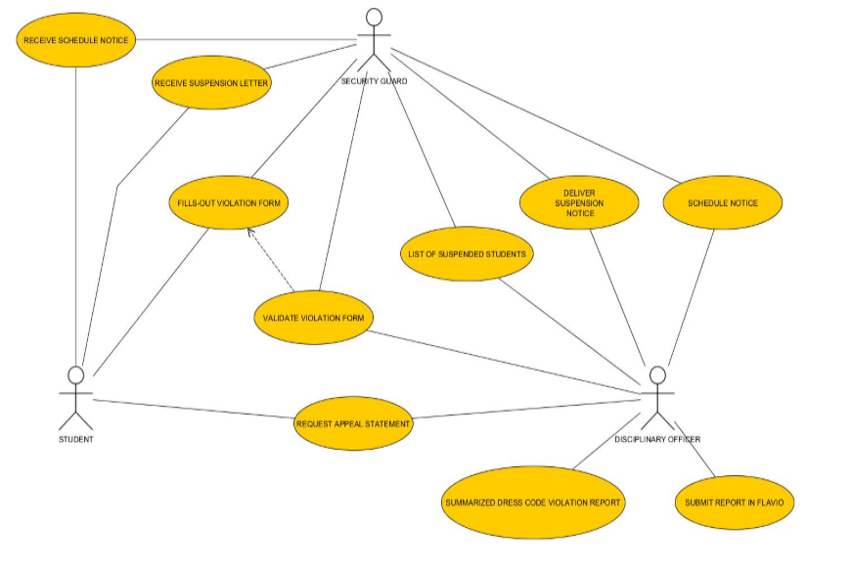**Business Use Case:**

**Solution:**

* Provide a web-based violation system which will have an efficient means of communication between the students and the Disciplinary Officer.

**Objectives:**

General Objectives

* To provide an efficient means of giving violation to students.
* To deter students from committing violations.

Specific Objectives

* To prevent students from using different student IDs to avoid suspension.
* To promote better authentication whenever students are given violations.
* To keep track and to remind students about their violation.
* To provide a trend analysis for each term and the corresponding academic school year.

**System Use Case:**

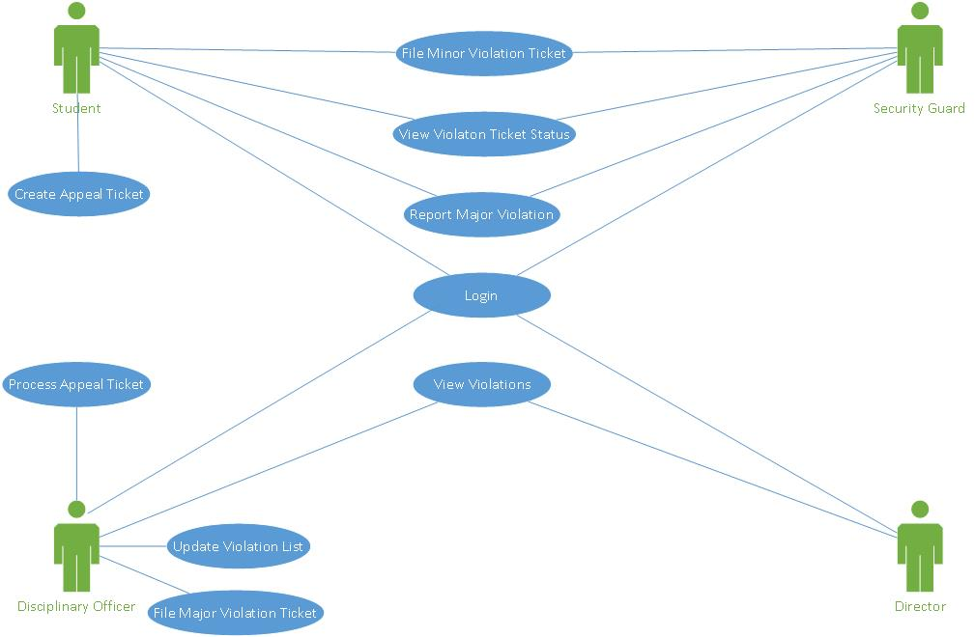

**General Features of the Violation System**

* There will be an admin page to create, read, update violation list.
* There will be a student page to view violations and create appeal ticket.
* There will be notifications in the student page, wherein they will know if they committed a violation, or if they are required to have a meeting with the Disciplinary Officer.

**Modules:**

**Dress Code Violation Module**

* The student either taps his id or type his student id number if a violation will be issued.
* The security guard must takes a picture of the student, and saves it in the violation form.
* The security guard must confirm the violation form by tapping his id to the scanner, before submitting it.

**Major and Minor Offense Filing Module**

* The Disciplinary Officer can update the list of violations if there is any revisions in the student hand book.
* Final decision for sanctions will be on the discretion of the Disciplinary Officer.

**Major and Minor Offense Reporting Module**

* Security guards and students can create a narrative report to report an incident within or outside the school premises.
* Student reports shall not be anonymous.

**Benefits:**

* Seamless reporting and filing of violations.
* Students will be aware of the violations they have committed; thus, it will promote discipline to the student body.
* Students who have committed a violation, but for a valid reason will be able to easily appeal to the Disciplinary Officer through the Student Page.
* If there will be any future revisions in the student hand book, the Disciplinary Officer could change the violation list and its details.